**University** **Education System**

**Group members:**

Jayashanker , Umair, Krishna

**System Purpose**:

* create a performance measurement solution to enable universities to measure the quality of the education they deliver to their students.
* look into how an educational system in terms of faculty and courses contribute to the growth of their graduates over a 5-year period.
* track the jobs and promotions graduates get over time and assign rankings accordingly.
* Study the relation between GPAs and Industrial success
* design a dashboard that enables college and university administrators to compare the performance of their academic units.
* enable the creation and update functions for any of the attributes of concern.

**Solution:**

It is important for university to keep updating their courses with changing technology, for that to happen it is crucial to assess and analyze the quality of education they are providing to students. When student graduates from university and gets an employment, we can review student’s performance and rank course offerings of University. To review students’ performance, it is important to take feedback from employer and students progress over a period as the time from graduation increases others factors also plays role in the student growth, hence we are considering students career growth of his/her 5 years duration of graduation.

**System Function:**

* University will have multiple departments and persons
* University admin will be able to update departments, persons related to university, Schedule and course offerings
* Each person in university is assigned a role
* Each department will have multiple courses
* Each course offering has a course and a faculty assigned to the course
* Students should be able to enroll in courses
* Grade should be given to each seat assignment of student
* Each student will have a transcript which will have students each semester course load and its corresponding Grade as well as cumulative grade
* Once student get employment it gets updated in student record
* Employer should be able to grade student based on his performance at job
* University should analyze employers feedback to update their course offerings

**Function Roles**

Create and update functions:

* DepartmentDirectory has list of all departments in the university
* PersonList has list of persons associated with the university
* FacultyList has list of persons who are faculty in University, similarly we have StudentDirectory. These Lists have all the respective values and whenever a object is created of Student or faculty, first person object is created and then it is updated in this list
* SemesterList has list of all semesters and course schedules are created for all semesters created
* In course schedule, all course offerings are given and in all course offerings courses are linked with faculty
* For all students in each department a transcript is generated which will have record of course load of a student in each semester, GPA secured in each course load, and cumulative GPA till now.
* Employers get register with university and a record of employer profile is generated in EmployerProfile
* Employer will be able to post jobs for university students
* Once students secure their jobs, their employment data will be recorded in their profile
* Employer will get a chance to rate the student on his performance with the company, so that university will have a feedback on their courses
* Once the student job performance is recorded then university will evaluate their course offerings and faculty

**Sequence Diagram for student assessment**

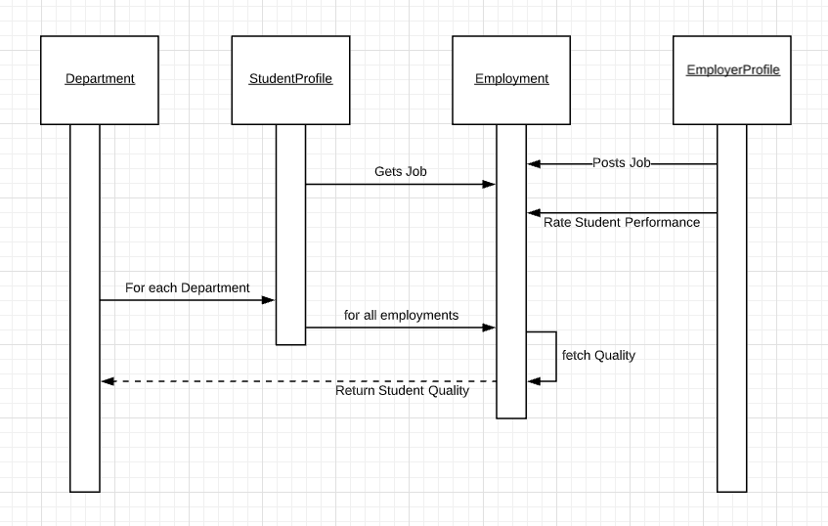

**Object Model diagram of University model:**

